**Team : Data Minds**

**Members:**

1. **Toksonbaeva Munavara ID12214686**
2. **Uriel PAcheco ID1225009**
3. **Alikhanova Zeinep ID12244669**
4. **Konno Malik Adams ID12250035**

**Tourism Preferences : AI tools**

**Introduction**

The travel sector has experienced a swift change due to the incorporation of artificial intelligence (AI), resulting in more intelligent and customized travel experiences. We love going to new locations, and we've seen how technology is affecting how we arrange our vacations. Our team wanted to learn more about these shifts, specifically how new tools might help young travelers like us. Travel isn't solely about vacations, it has an essential impact on the global economy, creating jobs and businesses all across the world. The pandemic changed everything. As travel patterns vary, AI systems need to adapt to address the unique requirements of different groups of travelers. This report analyzes three distinct traveler groups—budget-conscious, nature-loving, and family-centric—and describes how AI tools can improve their travel planning process. By utilizing clustering analysis and predictive modeling, we reveal insights into the interactions of various user groups with technology and investigate applicable AI solutions customized for each person.

**OLS Models to Analyze AI usage**

Ordinary Least Squares (OLS) regression models were applied to identify which variables significantly influence the likelihood that a traveler will use AI tools for trip planning.

Key variables from the survey—such as age, travel frequency, and planning style—were selected and modeled in relation to AI usage. The results made it possible to quantify the impact of each factor, showing, for example, that age has a negative effect (younger travelers use AI more) and that those who plan digitally are more likely to adopt these tools.

**Cluster Validation and Methodology**

To ensure that the segmentation of travelers was both meaningful and data-driven, we implemented the K-means clustering algorithm, a widely used unsupervised machine learning technique for grouping similar data points. A critical step in this process is determining the optimal number of clusters (K). To address this, we employed the “elbow method,” which involves running K-means for a range of cluster numbers and plotting the within-cluster sum of squares (inertia) for each value of K. The point where the decrease in inertia begins to level off—forming an “elbow” in the graph—suggests the most appropriate number of clusters, balancing model simplicity with explanatory power. In our analysis, this method indicated that three clusters best captured the primary traveler personas in the dataset.

Once the optimal K was established, K-means assigned each traveler to one of the three groups based on similarities across selected features such as travel frequency, purpose, accommodation preference, planning style, and openness to AI. This approach allowed us to objectively identify and describe the budget-conscious, nature-loving, and family-centric traveler segments, ensuring that the resulting personas were grounded in real behavioral patterns rather than subjective assumptions.

**Traveler Grouping: Recognizing User Categories (Clustering)**

We applied unsupervised machine learning methods to a dataset obtained from traveler behavior surveys. Taking into account factors like travel frequency, reason for travel, lodging preference, planning resources, and comfort with AI, we determined these three groups:

**Cluster 1:**

-Infrequent Travelers Who Mind Their Spending

-Journey rarely, primarily for enjoyment or holidays.

-Choose hotels or economical lodging options.

-Extremely responsive to changes in costs and prices.

-Indifferent or wary regarding AI instruments.

**Cluster 2:**

-Nature Enthusiasts with a Tech Savvy Attitude

-Travel often and appreciate distinctive, nature-centered experiences.

-Receptive to different kinds of lodging options.

-Depend significantly on social media and online planning resources.

-Eager proponents of AI for personalized travel arrangements

**Cluster 3:**

-Family Visitors Worried About Language Obstacles

-Journey to see family or acquaintances.

-Typically reside with relatives or nearby hosts.

-Least probable to utilize AI

-Primary issue: comprehension of language and culture.

# **AI Model Implementation**

To identify user clusters and predict AI readiness, we applied machine learning models such as k-means clustering and regression analysis. The process pipeline includes survey data, feature selection, clustering, and insights generation.

**Benefits and Drawbacks Benefits**

Travel platforms may leverage these personas for improved targeted offerings. AI-driven tools improve user satisfaction, reduce decision fatigue, and increase the likelihood of bookings. Challenges: Some travelers may not trust AI or may lack access to digital tools. AI systems must be multilingual, culturally aware, and considerate of privacy. Over reliance on AI could reduce serendipitous travel experiences.’

**Conclusion**

AI holds significant promise to revolutionize the ways individuals plan, reserve, and enjoy travel—particularly when resources are designed to accommodate the varied needs of travelers. By organizing users into practical groups and creating tools such as BudgetBot, AI Guides, and AR-infused itineraries, the travel sector can connect technology with human feelings.

**References**

1. T. Nguyen et al., “AI in Travel: From Prediction to Personalization,” *Journal of Tourism Technology*, vol. 15, no. 2, pp. 101–118, 2023.
2. S. Patel, “Clustering Travelers Using Behavioral Data,” *Data Science in Practice*, 2022.
3. Hopper.com. “How Our Price Prediction Algorithm Works.” [Online]. Available:<https://www.hopper.com/>
4. Google. “Translate & Lens Tools.” [Online]. Available:<https://translate.google.com/>
5. Research, Z. M., & Research, Z. M. (2025, May 15). *Global Tourism Market Size, Share, Growth, Analysis, and Forecast 2032*. Zion Market Research. <https://www.zionmarketresearch.com/report/tourism-market>
6. *Tourism Statistics 2024 | How many tourists globally?* (n.d.). Road Genius. <https://roadgenius.com/statistics/tourism/global-tourism-2024-forecast/>
7. *Tourism preferences*. (n.d.). Google Docs. <https://docs.google.com/forms/d/1RXF5JPG-1GuOTKuW-wZJYnfFhmIH4vaHqzP0KfJYhzU/edit?pli=1#responses>
8. *Global and regional tourism performance*. (n.d.). <https://www.unwto.org/tourism-data/global-and-regional-tourism-performance>

**Appendix**

**OLS Models**

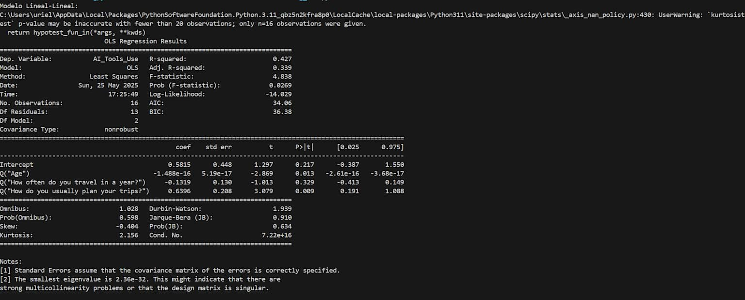

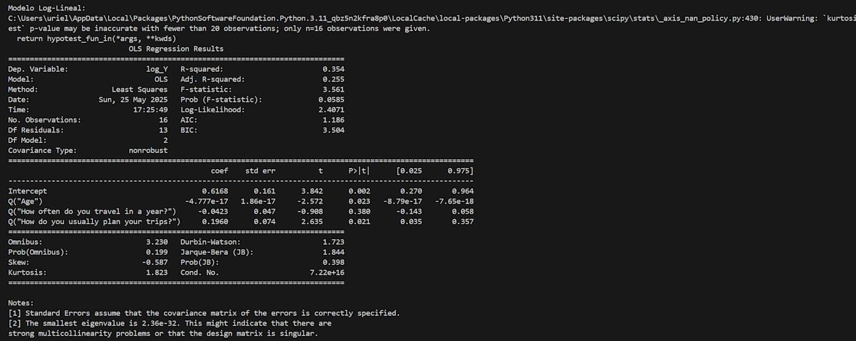

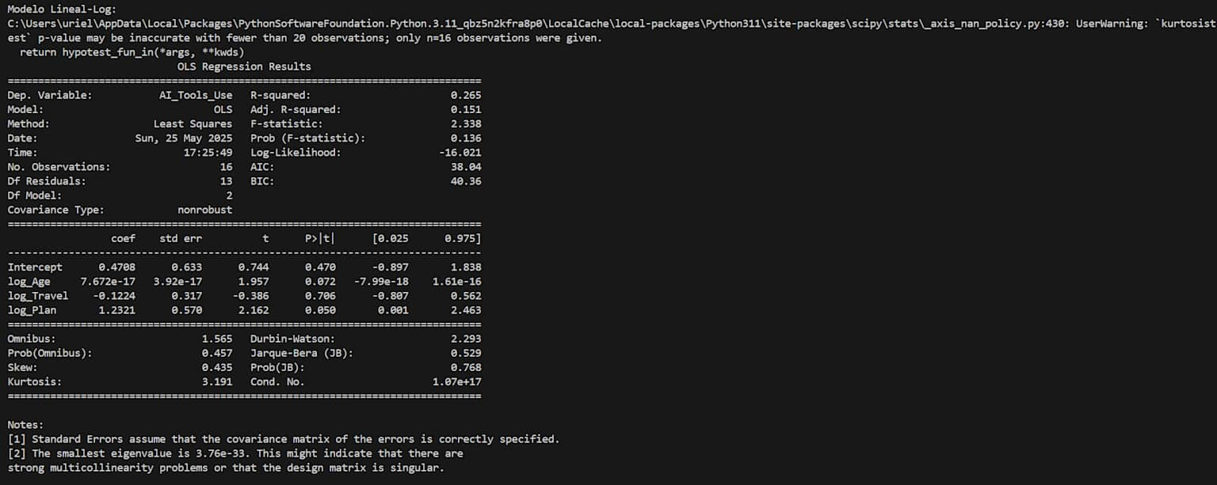

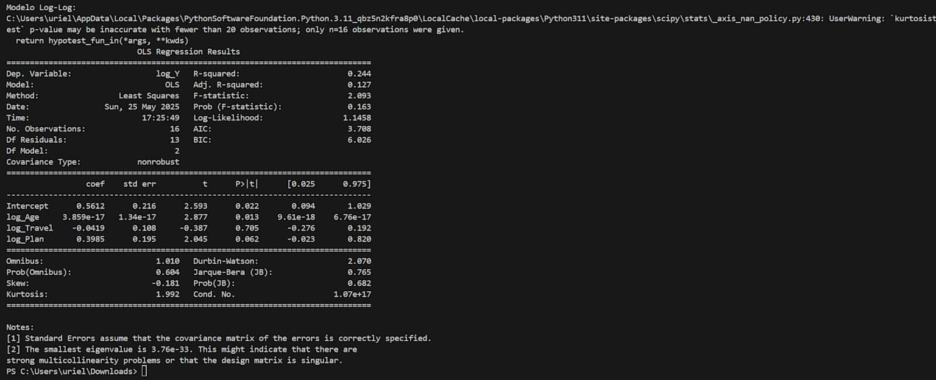

**Clustering**

